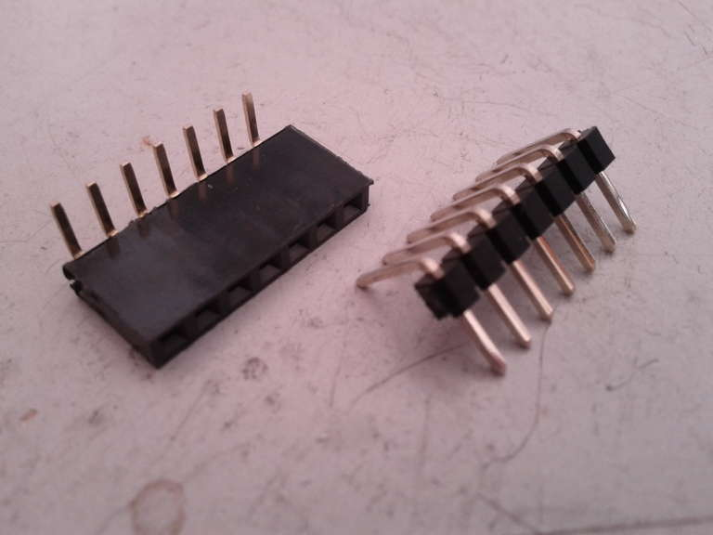
Large 7 segment LED display
Date: | 09/05/13 | Version: | 1.0 | By: | Matt Little

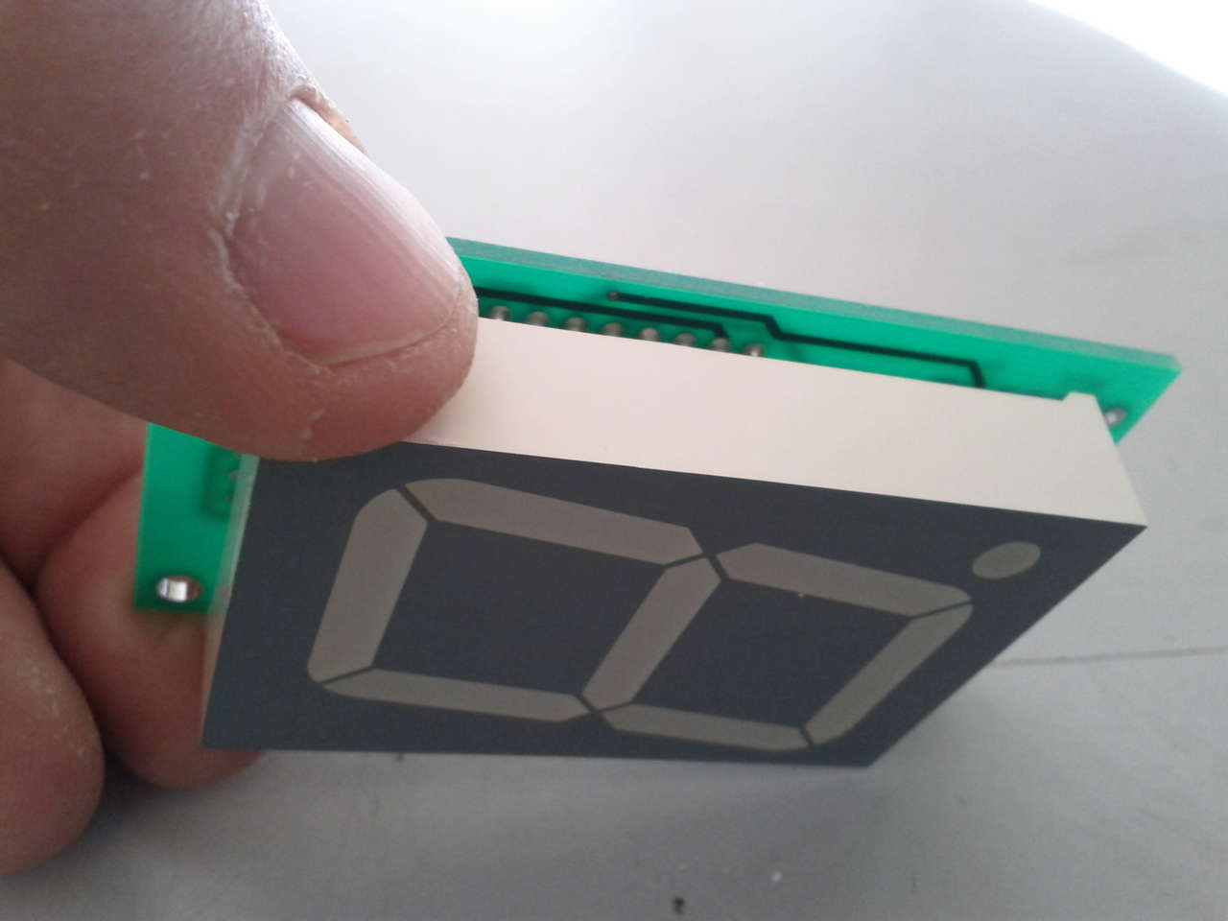  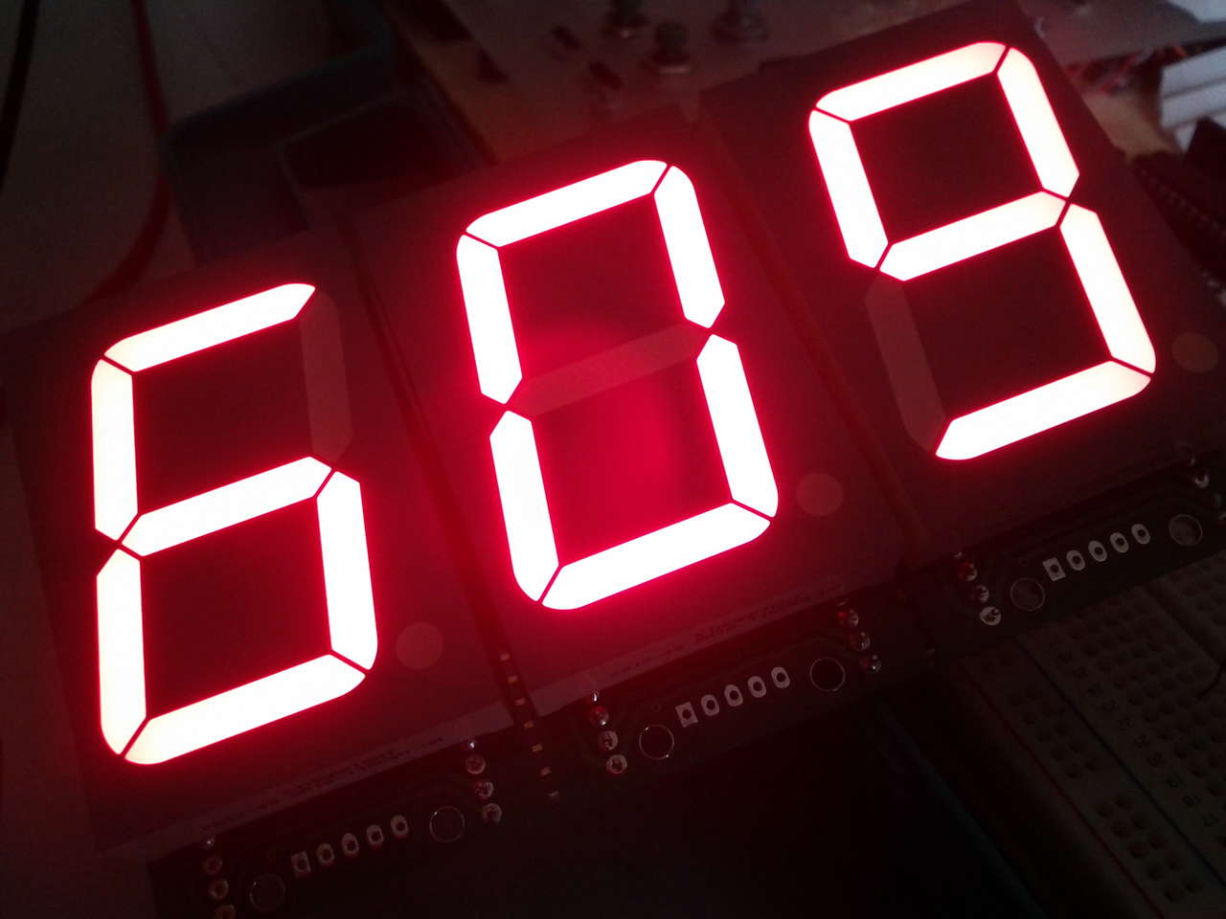 | Ever needed to have a large visual numerical display?  This kit is a series connected large 7 segment LED driver.  It can drive a 1.75” (45mm) LED unit (included)  It requires 12V to function.  It is designed to connect to an Arduino or other micro-controller. Example code for the Arduino is available.  A 74HC595 shift register is used along with a UN2003 transistor array.  The decimal point can also be utilised.  Note: this kit will require an Arduino or other micro-controller to run.
Parts included:
 |  |  | 1 x 7 way female header |  |  |  |  | 1 x 7 way male header
1 x 45mm  Super Bright  7 segment  LED  Display | 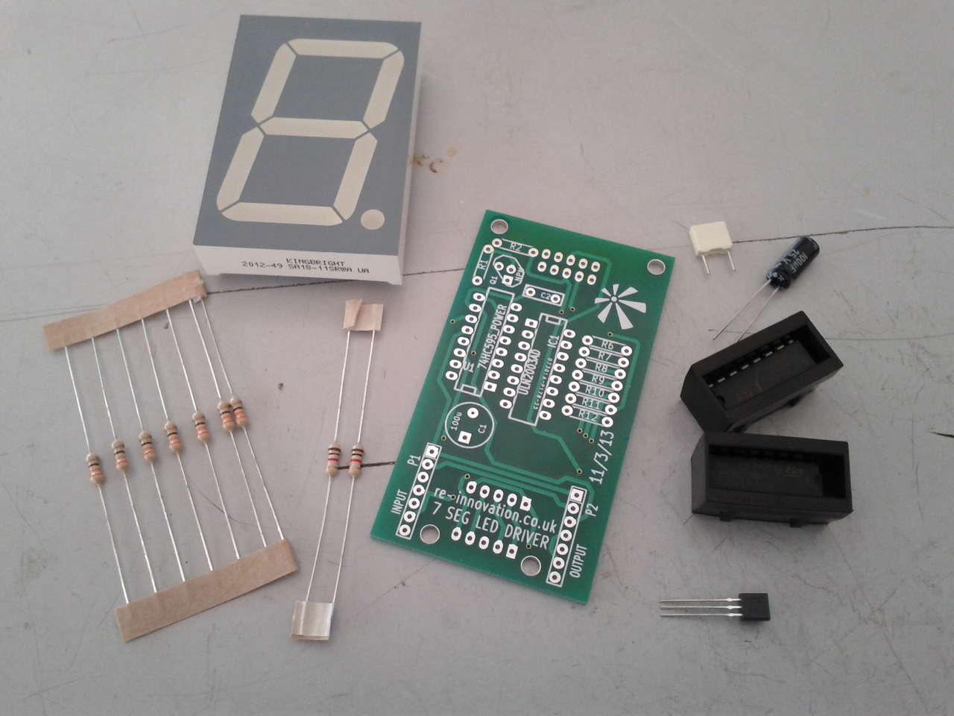 |  |  |  |  |  |  | 1 x 7 way male header
1 x 45mm  Super Bright  7 segment  LED  Display |  |  |  |  |  |  |  | 100nF  Capacitor
1 x 45mm  Super Bright  7 segment  LED  Display |  |  |  |  |  |  |  | 100uF Capacitor
 |  |  |  |  |  |  |  | 74HC595
7 x 330  Resistors |  |  |  |  |  |  |  | UN2003
 |  |  |  |  |  |  |  | BC548
0.1uf Capacitor
(not shown)
 |  | 2 x 1k  Resistors |  | PCB

Parts list:
Ref | Description | Value/Code
7SEG1 | Super Bright Common Annode. 7 Segment LED. Kingbright. 45mm | SA18-11_CA
C1 | Decoupling capacitor | 100uf
C2 | Decoupling capacitor | 100nf
C | Filter capacitor (not on diagram) | 0.1uf
IC1 | Transistor array | ULN2003AD
P1 | INPUT | 6 way 90 degree pin
P2 | OUTPUT | 6 way 90 degree socket
Q1 | NPN for Decimal Point | BC548
R1 | Limit transistor base current | 1k
R2 | Limit current to DP | 1k
R6 | Limit current to LED chain | 330
R7 | Limit current to LED chain | 330
R8 | Limit current to LED chain | 330
R9 | Limit current to LED chain | 330
R10 | Limit current to LED chain | 330
R11 | Limit current to LED chain | 330
R12 | Limit current to LED chain | 330
U1 | Shift register | 74HC595_POWER
 | Circuit board | PCB
Tools required:
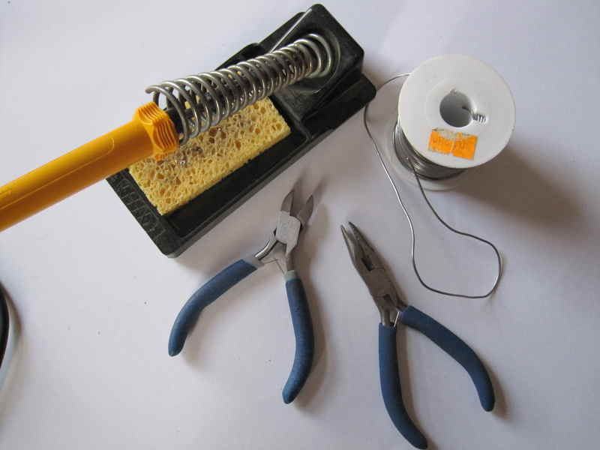
Soldering Iron
Solder
Side cutters
Small nosed pliers

This kit has been designed and produced by:
Renewable Energy Innovation.
info@re-innovation.co.uk
www.re-innovation.co.uk
Hopkinson Gallery, 21 Station Street, Nottingham, NG7 6PD
Instructions:
Step: 1 | Solder the resistors
Identify all the resistors. You will have:  Use the identify chart at the end of these instructions or a multimeter.  Solder into the relevant places.  Their orientation does not matter. |  | 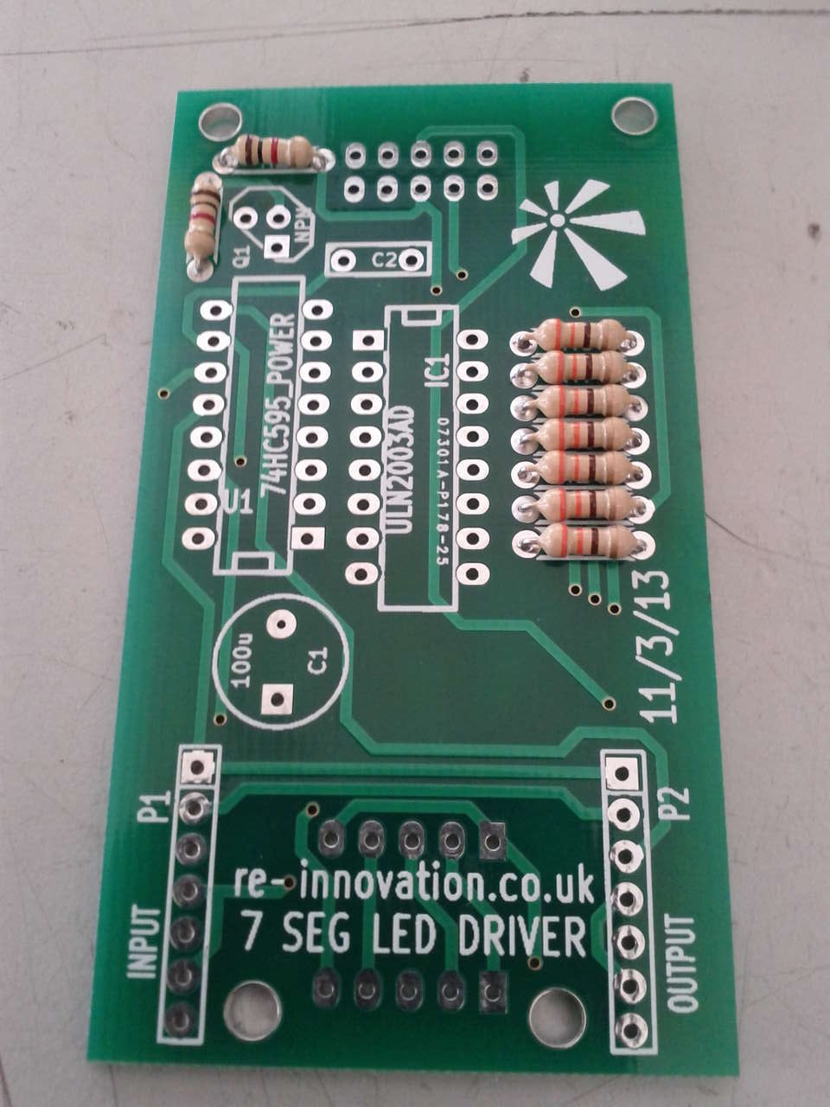
  Quantity | Value | Part Reference
  2 | 1k | R1,2
  7 | 330 | R6 to R12

Step: 2 | Solder the capacitors C1 and C2
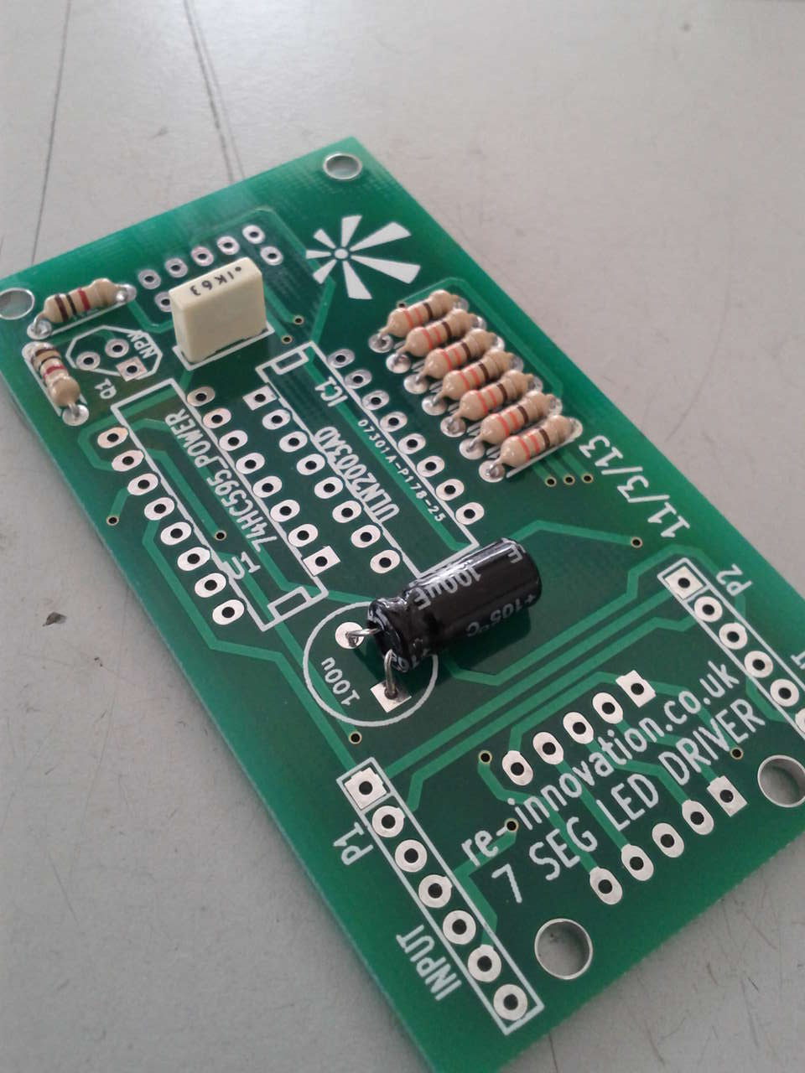 |  | Identify and then solder in the capacitors.  Check the orientation of C1. The white line on the side of C1 signifies negative side. The round pad on the PCB signifies negative. The longer lead signifies positive. The square pad on the PCB is positive.  To reduce the height of these components, bend over C1 as shown in the photo.
  Quantity | Value | Reference | Photo
  1 | 100uf | C1 | 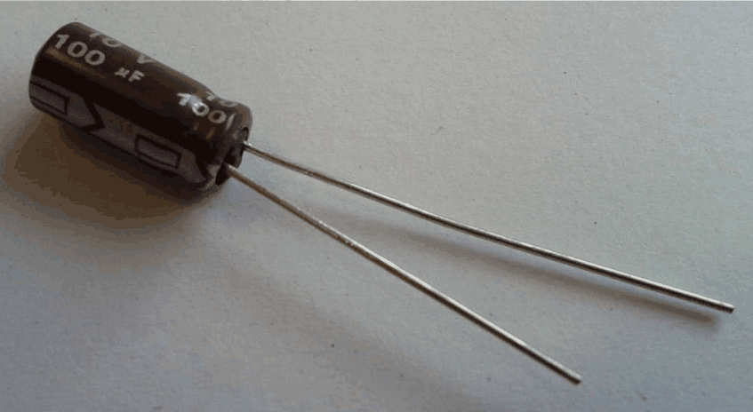
  1 | 100nf | C2 | 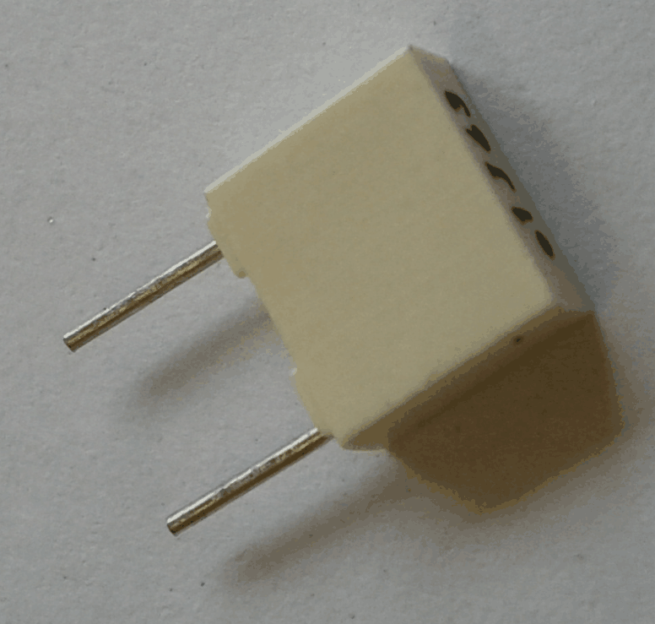

Step: 3 | Solder the transistor
Check BC548 orientation.  This fits into Q1 |  | 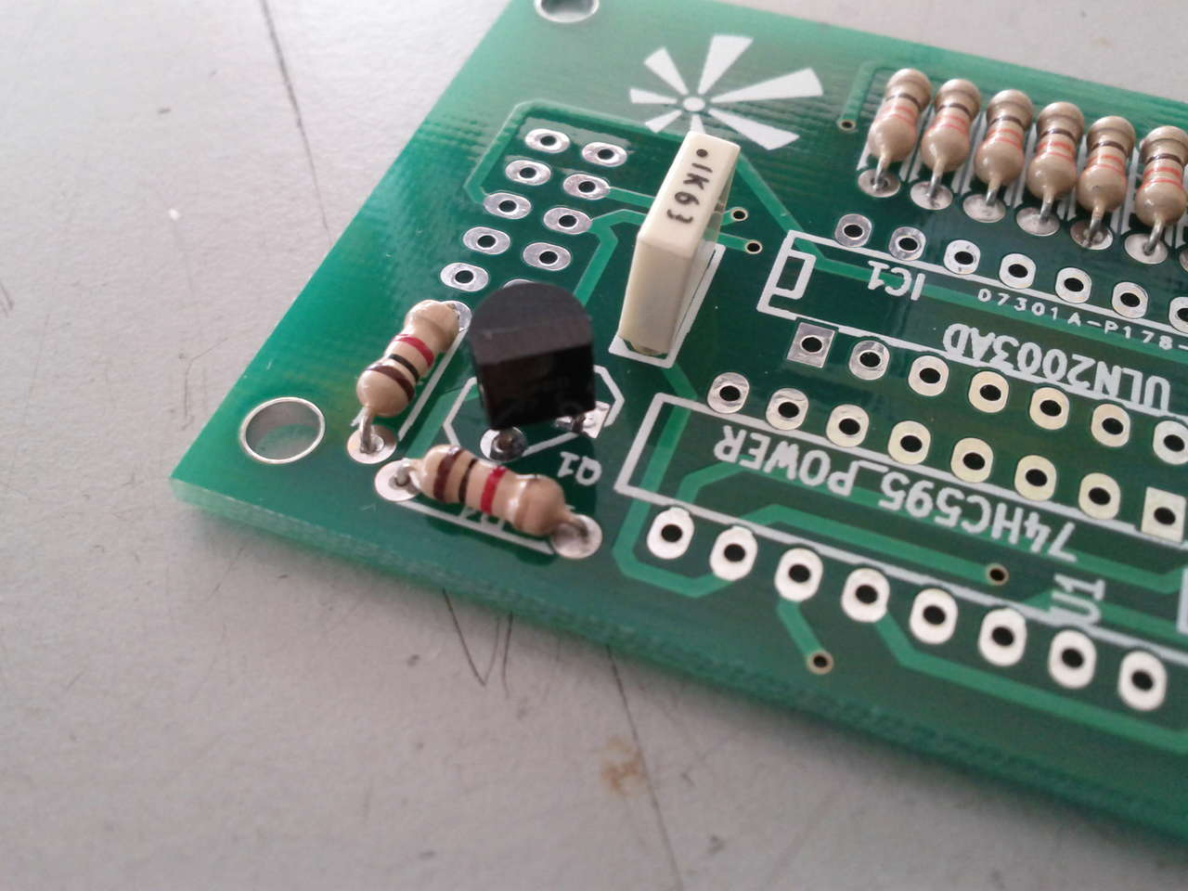

Step: 4 | Solder the 74HC595 shift register
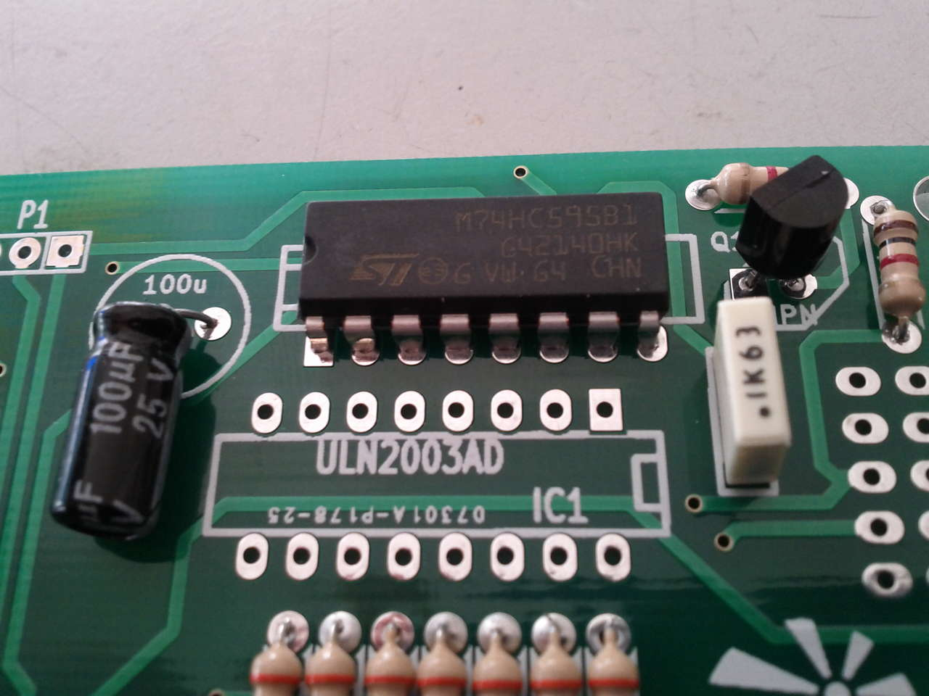 |  | To keep the profile low, no IC holders are used in this design. You can add them if you would like to.  Ensure the 74HC595 is fitted into the correct socket.  Ensure the notch on the component lines up with the notch on the circuit board silk-screen.  DOUBLE CHECK THIS (if soldering directly in). It will be VERY difficult to change if you get it wrong.

Step: 5 | Solder the UN2003 transistor array
To keep the profile low, no IC holders are used in this design. You can add them if you would like to.  Ensure the UN2003 is fitted into the correct socket.  Ensure the notch on the component lines up with the notch on the circuit board silk-screen.  DOUBLE CHECK THIS (if soldering directly in). It will be VERY difficult to change if you get it wrong. |  | 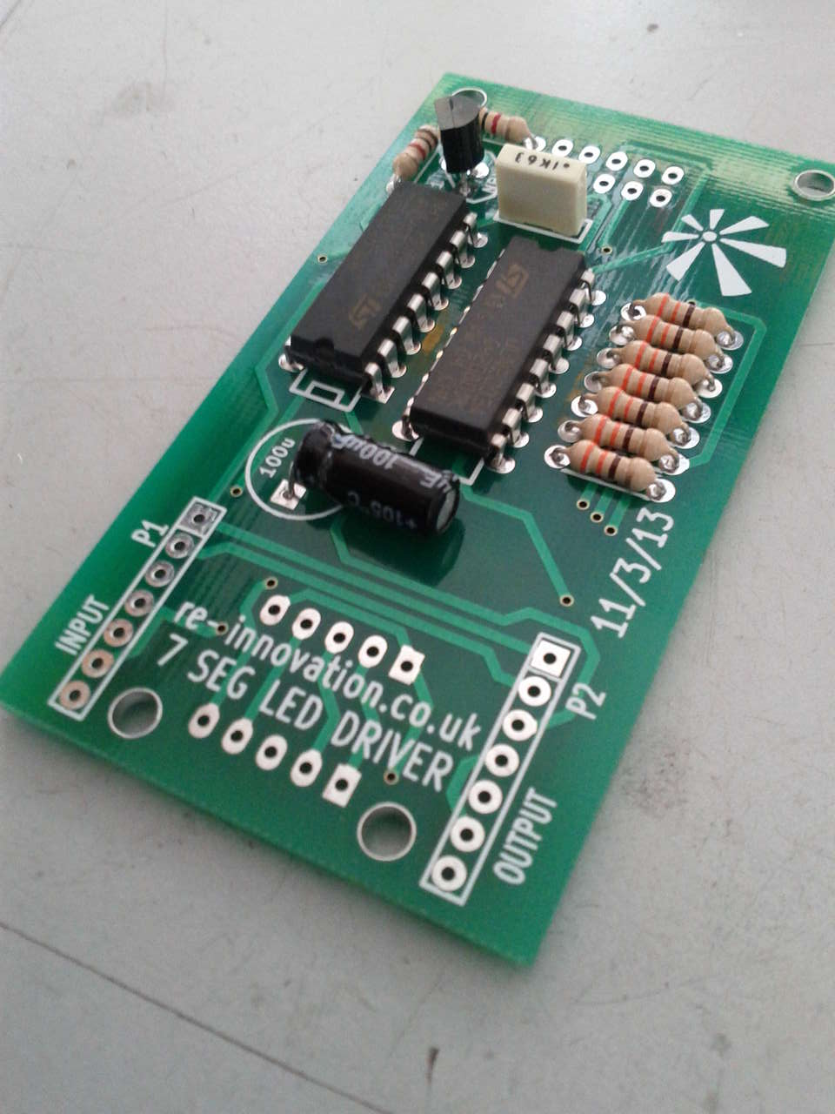

Step: 6 | Solder on P1 and P2 connectors
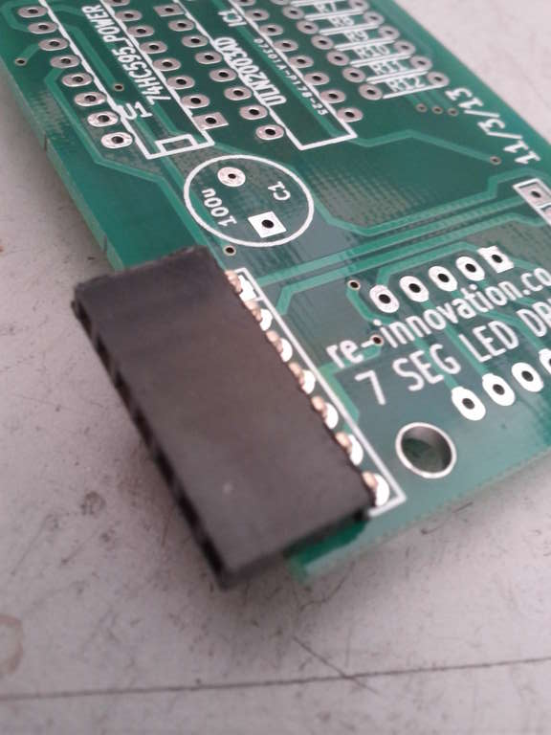  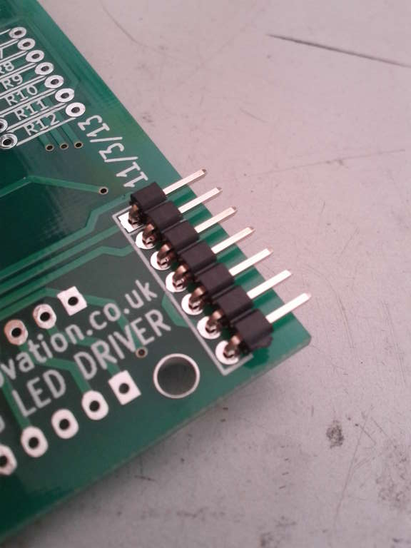  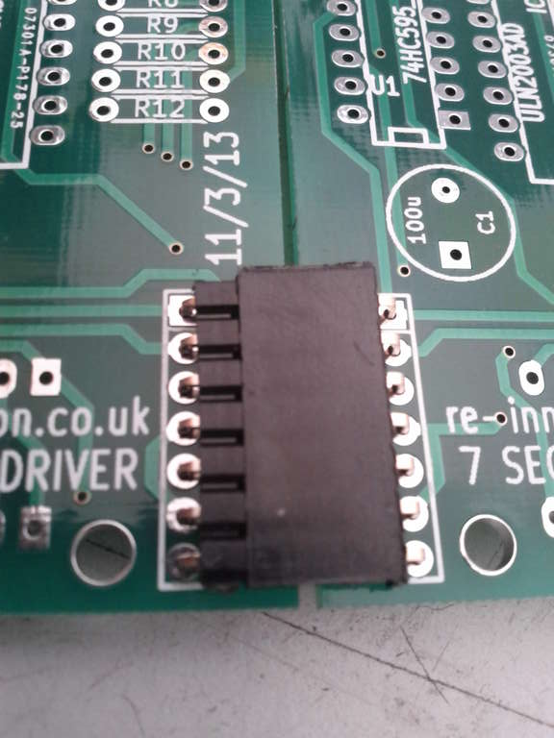 |  | If you are going to link up a number of these units then you will need to add the INPUT and OUTPUT connectors. These are labelled P1 and P2.  To do this there are 7-way male and female header pins. I place the male in P2 (the output) and the female in P1 (the input).  In order for the connector to lie flat, the male header pins are NOT inserted in the usual way.  Instead we use the longer pins to go into the PCB (see photo).  Solder them in.  The black plastic strip can then be pushed back to expose more of the pins.  Cut off the excess from the pins through the circuit board.  These connectors are only needed if you are putting two or more boards together.

Step: 7 | Solder the LED display
The LED display is soldered on the reverse (solder) side of the PCB. This makes the whole unit much thinner.  You must ensure the correct orientation of the display.  The decimal point goes towards the bottom right hand corner of the PCB when looking at the solder side. The decimal point is on the end with P1 and P2, the input and output connections.  DOUBLE CHECK THIS (if soldering directly in). It will be VERY difficult to change if you get it wrong. |  | 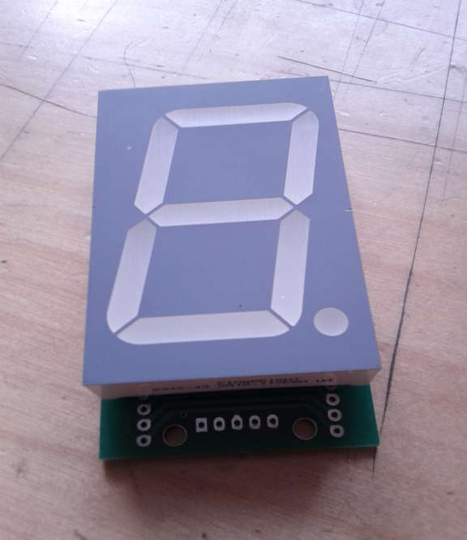  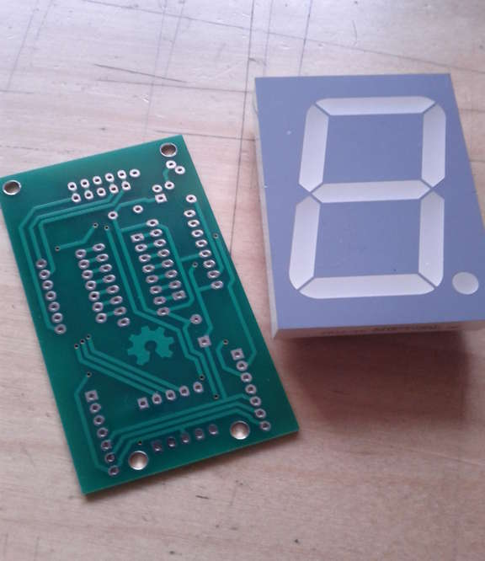  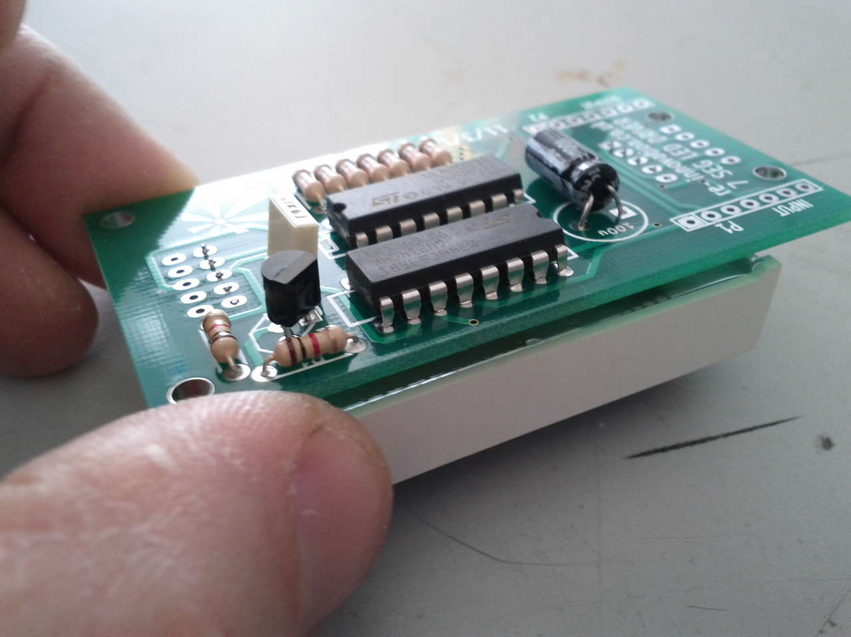

Step: 8 | Build is finished!
 |  | Have a nice cup of tea.

Once the device is constructed, the next step is check it powers up OK and then to test with a programmed Arduino....

Step: 9 | Connect to an Arduino
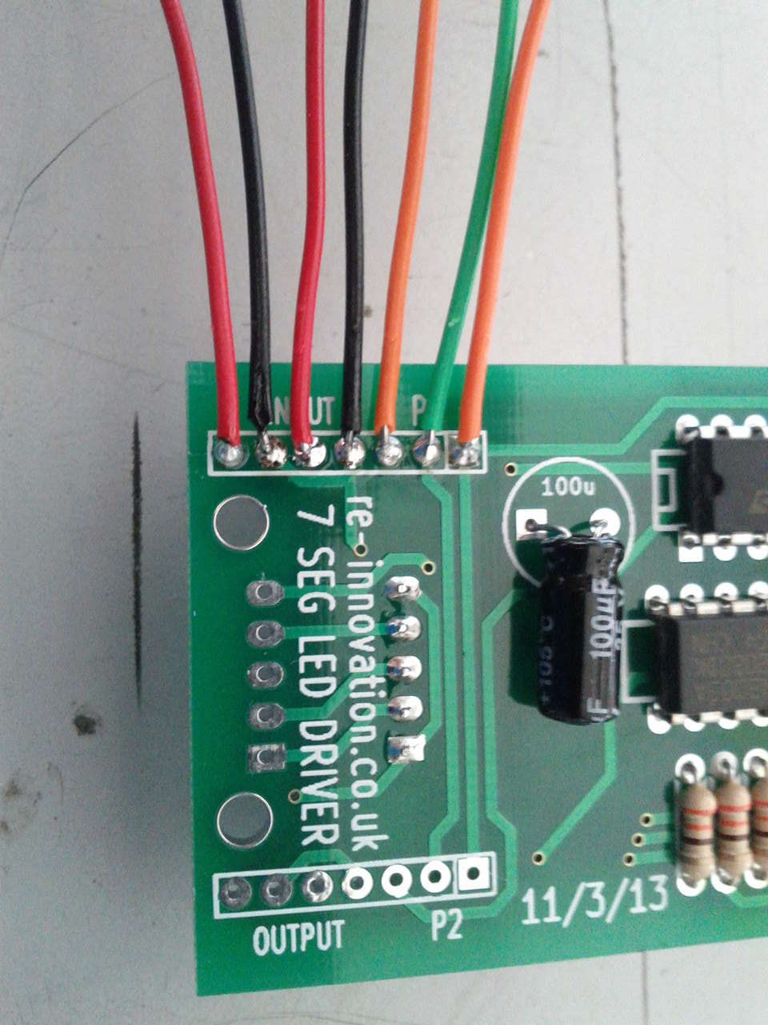  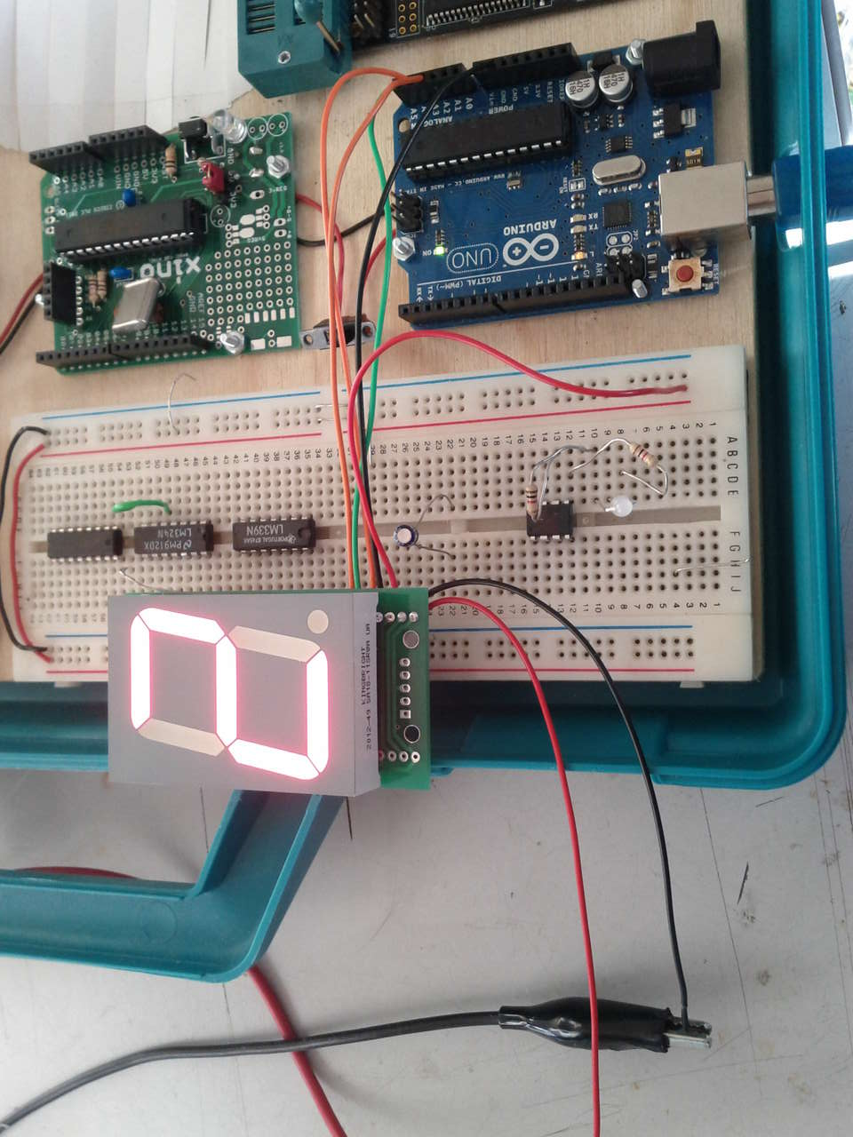 |  | There are 7 connections to the 7 segment LED boards. Pin 1 is the square pad. The connections are:  Pin 1 → Serial LATCH → A3 Arduino  Pin 2 → Serial CLOCK → A5 Arduino  Pin 3 → Serial DATA → A4 Arduino  Pin 4 → GROUND → GND Arduino  Pin 5 → +5V → +5Arduino  Pin 6 → GROUND  Pin 7 → +12V  In the example code for the Arduino, pin 1 (LATCH) is connected to A3, pin 2 (CLOCK) is connected to A5 and pin 3 (DATA) is connected to A4. The Ground and +5 must also be connected.

Step: 10 | Upload the example sketch
Note: These instructions assume you are familiar with the Arduino IDE and uploading Sketches. If not search online for some great tutorials.
This was tested on version 1.02.

Download the example code from www.re-innovation.co.uk.
Add this to your sketches folder.
Open and upload to your Arduino.

This should then run through the various example functions.
Check the notes within the code for more details.

Step: 11 | Apply a 12V power supply
The LED unit requires 12V DC to operate. This is due to the large size of the LED display, with four LEDs in each segment. The required voltage must be 8V or higher. The 330 ohm resistors limit the current from the 12V supply.

Apply 12V to pins 6 (Ground) and 7 (+12V DC). Use an adjustable current limit power supply (if possible) when testing this. If there are any bad connections, check your soldering and orientation of all components.
Note: If using a battery the ALWAYS ensure there is a fuse in the 12V power line.

Step: 12 | Set it running
Check out www.re-innovation.co.uk for more examples and videos.

Note: If the display flickers when updated, you might need a 0.1uF capacitor (included) between Pin 1 (LATCH) and Pin 4 (Ground). Attach this to the output connector of the last display in your serial chain.

See the ShiftOut example on the Arduino reference website for more information:
http://arduino.cc/en/Tutorial/ShiftOut

Step: 13 | Build your project
Check www.re-innovation.co.uk for some examples of this kit in action.
We would love to hear and see your application and ideas. Please email any photos to info@re-innovation.co.uk, or leave comments.
Arduino code information:
An example sketch for getting your project running is available at www.re-innovation.co.uk.
Contact details:
We would like you to be happy with this kit. If you are not happy for any reason then please contact us and we can help to sort it out. Please email info@re-innovation.co.uk with any questions or comments.
If any parts are missing from your kit then please email info@re-innovation.co.uk with details, including where the kit was purchased.

More technical information can be found via www.re-innovation.co.uk.
Useful Information:

Circuit schematic:

Printed Circuit Board
(not to scale!)
